***power supply***

The power supply unit is the part of the hardware that is used to convert the power provided from the outlet into usable power to many parts inside an electrical device. Every energy supply must drive its load, which is connected to it. Depending on its design, a power supply unit may obtain energy from various types of energy sources, like [electrical energy transmission systems](https://www.elprocus.com/flexible-ac-transmission-system-need-definition-types/), electromechanical systems such as generators and alternators, solar power converters, energy storage devices such as a battery and fuel cells, or other power supply. There are two types of power supplies existed, AC and DC power supply. Based on the electrical device’s electric specifications it may use AC power or DC power.

**What is a Power Supply?**

The power supply can be defined as it is an electrical device used to give electrical supply to electrical loads. The main function of this device is to change the electrical current from a source to the accurate voltage, frequency and current to supply the load. Sometimes, [these power supplies](https://www.elprocus.com/types-power-supplies/) can be named to as electric power converters.

## ****Power Supply Block Diagram****

The Power supply circuit is used in various electrical & electronic devices. The power supply circuits are classified into different types based on the power they utilize for providing for circuits or devices. For instance, the microcontroller based circuits are generally the 5V DC regulated power supply (RPS) circuits, which can be designed with the help of different method for changing the power from 230V AC to 5V DC.

The power supply block diagram, and the step by step conversion of 230V AC to 12V DC is discussed below.

* A step-down transformer converts the 230V AC into12v.
* The bridge rectifier is used to change AC to DC
* A capacitor is used to filter the AC ripples and gives to the voltage regulator.
* Finally voltage regulator regulates the voltage to 5V and finally, a blocking diode is used for taking the pulsating waveform.

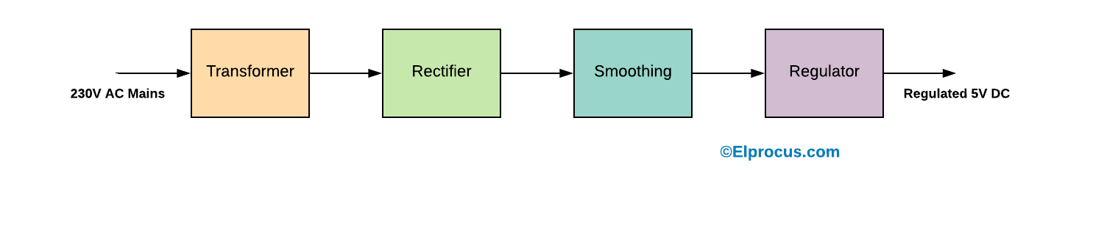

### Linear Power Supply

### Unregulated Linear Power Supply

Unregulated power supplies contain a step-down transformer, rectifier, filter capacitor, and a bleeder resistor. This type of power supply, because of simplicity, is the least costly and most reliable for low power requirements. The main disadvantage is that the output voltage is not constant. It will vary with the input voltage and the load current, and the ripple is not suitable for electronic applications. The ripple can be reduced by changing the filter capacitor to an LC (inductor-capacitor) filter, but the cost becomes more.

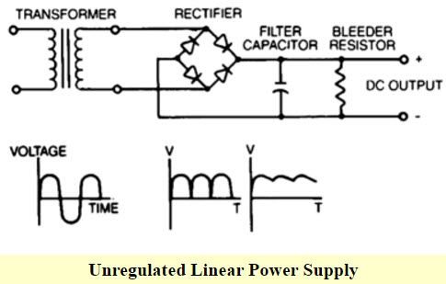

**Input transformer**

The input transformer is used to convert the incoming line voltage down to the required level of the power supply. It also isolates the output circuit from the line supply. Here we are using a [step-down transformer](https://www.elprocus.com/steps-to-convert-the-230v-ac-to-5v-dc/).

**Rectifier**

The rectifier used to convert the incoming signal from an AC format into raw DC. Please refer these links, Different types of rectifiers available are [half wave rectifier](https://www.elprocus.com/differential-pulse-code-modulation-working-application/)and [full-wave rectifier](https://www.elprocus.com/full-wave-rectifier-circuit-working-theory/).

**Filter Capacitor**

The pulsated DC from the rectifier is fed to the smoothing capacitor. It will remove the unwanted ripples in the pulsated DC.

**Bleeder Resistor**

Bleeder Resistor is also known as a power supply drain resistor. It is connected across the filter capacitors to drain their stored charge so that the power system supply is not dangerous.

### Regulated Linear Power Supply

Regulated linear power supplies are same as the unregulated linear power supply except that[a 3-terminal regulator](https://www.elprocus.com/lm340-series-voltage-regulators/)is used in place of the bleeder resistor. The main aim of this supply is to provide the required level of DC power to the load. The DC power supply uses an AC supply as the input. Different applications require different levels of attributes voltages, but nowadays the DC power supplies provide an accurate output voltage. And this voltage is regulated by an electronic circuitry so that it provides a constant output voltage over a wide range of output loads.

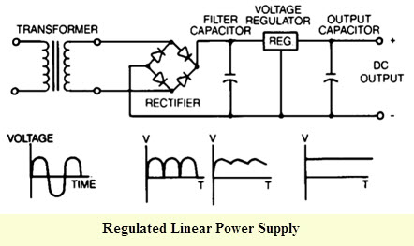

The main features of this power supply include the following.

* The efficiency of this power supply ranges from 20 to 25%
* The magnetic materials used in this power supply are CRGO core or Stalloy.
* It is more reliable, less complex and bulky.
* It gives a faster response.

The main advantages of linear power supply include reliability, simplicity, low cost and the noise level is low. Along with these benefits, there are some disadvantages such as

These are best for several low power applications as a result when a high-power is required; the drawbacks turn into more clearly. The disadvantages of this power supply include a high loss of heat, size, & low-efficiency level. Whenever linear power supply is used in high power applications; it requires large components to manage the power.

**Smoothing**

Once rectified from an AC signal, the DC needs to be smoothed to remove the varying voltage level. Large value capacitors are generally used for this purpose.

### ***Switch Mode Power Supply (SMPS)***

SMPS power supply transfers power from a source — usually an AC outlet — to a DC device. What sets the SMPS apart is its ability to regulate the output voltage. It can increase or decrease the output voltage to maintain a constant output regardless of changes in load. This dual ability gives it an advantage over linear regulators, which can only regulate the output down (that is, they can only decrease the voltage, not increase it)

**SMPS OPERATION**

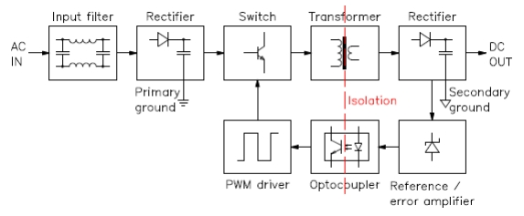

1. The diagram above outlines how the SMPS operates. An SMPS ’s functionality is more complex than that of a linear regulator, but we can break it down into five stages:
2. In the first stage, the incoming AC power runs through a rectifier and undergoes filtration to produce DC
3. The SMPS works at high frequencies, so a high-frequency switch processes the DC signal, which creates a high-frequency pulsating DC signal
4. The power transformer steps down the high-voltage DC signal to a DC signal of the appropriate level
5. The stepped-down DC signal is rectified and filtered to a achieve a steady, constant DV output
6. The control circuitry monitors the output voltage and adjusts the high-frequency switch on-the-fly to ensure a continuous output stream of the desired voltage

**Advantages of SMPS**

* The SMPS designs are more compact and use smaller transformers. The ability to shrink the supplies is an advantage and an essential requirement for most of the electronic devices with limited space
* High efficiency 68% to 90%
* Flexible technology
* The transformer-isolated supplies have stable outputs independent of the input supply voltage
* High power density

**Disadvantages of SMPS**

* Extra external components which also requires more space
* Generation EMI and electrical noise
* Complex design
* Costly due to extra components

Comparison Chart

| **PARAMETERS** | **LINEAR POWER SUPPLY** | **SWITCH MODE POWER SUPPLY (SMPS)** |
| --- | --- | --- |
| Definition | It completes the stepping down of AC voltage first then it converts it into DC. | It converts the input signal into DC first then it steps down the voltage up to desired level. |
| Efficiency | Low efficiency i.e. about 20-25% | High Efficiency i.e. about 60-65% |
| Voltage Regulation | Voltage regulation is done by voltage regulator. | Voltage regulation is done by feedback circuit. |
| Magnetic material used | Stalloy or CRGO core is used | Ferrite core is used |
| Weight | It is bulky. | It is less bulky in comparison to linear power supply. |
| Reliability | More reliable in comparison to SMPS. | its reliability depends on the transistors used for switching |
| Complexity | Less complex than SMPS. | More complex than Linear power supply. |
| Transient response | It possess faster response. | It possess slower response. |
| RF interference | No RF interference | RF shielding is required as switching produces more RF interference. |
| Noise and Electromagnetic interference | It is immune to moise and electromagnetic interference. | Effect of noise and electromagentic interference is quite significant, thus EMI filters are required. |
| Applications | Used in Audio frequency applications and RF applications. | Used in chargers of mobile phones, DC motors etc. |

